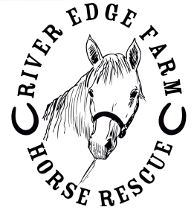 River Edge Farm Horse Rescue, Inc.
Thank you for sponsoring a horse in need. You can sponsor the horse(s) of your choice online or through the mail. To make your donation by mail, please print out this form and fill out the requested information. This form is for Sponsorships only.

SPONSORSHIP FORM

First Name _______________________________ Last Name_________________________________
Address _____________________________________________________________________________
City __________________________ State ______________________ Zip _______________________
Phone __________________________________ E-Mail ______________________________________
How did you hear of us? ______________________________________________________________

I would like to sponsor:

Horse’s Name 2 months 3 months 6 months 1 year
_________________ 􀁔 􀁔 􀁔 􀁔
_________________ 􀁔 􀁔 􀁔 􀁔
_________________ 􀁔 􀁔 􀁔 􀁔
_________________ 􀁔 􀁔 􀁔 􀁔

Amount $ ________ $ _________ $ ________ $ _________

River Edge Farm Horse Rescue does not offer a one month sponsorship. However, if you wish to support a horse and pay monthly, please fill out the following:

I would like to sponsor ___________________ on a monthly basis @ $_______/month for ______ months.

Or, you may designate you wish to contribute to the hay fund, feed, Veterinary care, here:
_____________________________________________________________________________________

Please choose one of the following payment options:

􀁔 Payment by mail – please send your check payable to River Edge Farm Horse Rescue with this form to:
Sponsorships
River Edge Farm Horse Rescue
P O Box 692
Lyles TN 37098

􀁔 Payment via PayPal – Click on the PayPal link on our Sponsor page. Please be sure to add your Sponsorship information in your PayPal transaction notes, or contact us by email.

Thank you!
River Edge Farm Horse Rescue, Inc. is a federal 501 (c) 3 not for profit corporation dedicated to helping horses in need.
All sponsorships and other donations are tax deductible to the fullest extent of the law.

