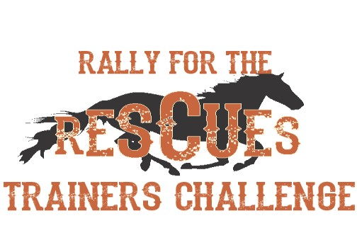
Rally for the Rescues-Trainers Challenge Sponsorship Levels for 2020

$2,500+ HORSES HEROES
• Business Logo and link on event Facebook page
• Premier logo placement on ALL event promotional materials, including all advertisements, and press releases
• Business included in all forms of advertising, print, video or radio
• Priority location for Vendor Booth at Trainers Challenge Event
• Company Banner at Trainers Challenge Main Arena plus VIP seating and admission for 6

$1,000+ GOLD BUCKLE SPONSOR
• Business Logo and link on event Facebook page
• Logo placement on printed promotional materials
• Company Banner at Trainers Challenge Main Arena plus VIP seating and admission for 4
• Vendor Booth at Trainers Challenge Event

$500+ SILVER BUCKLE SPONSOR
• Business Logo and link on event Facebook page
• Logo placement on printed promotional materials
• Corporate Banner at Trainers Challenge Main Arena plus VIP seating and admission for 2
• Vendor Booth at Trainer Challenge Event

COWBOY UP SPONSOR- $250 or $250 in products +
Business Logo and link on event Facebook page
Vendor Booth at the event
Admission for 2

BUCKLE UP $125-150
Sponsor a division buckle!
We will need a total of 13 buckles.

**All sponsors and vendors on site will be required to provide General Liability Certificate of Coverage**

